**3.1 Learning Objectives**

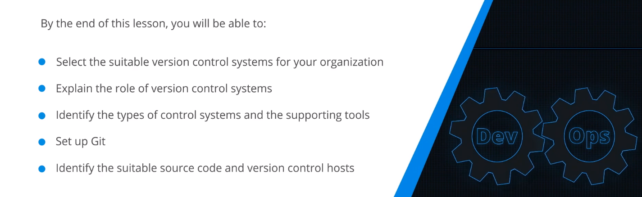

**3.2 Overview of Version Control Systems**

History of Version Control Systems:

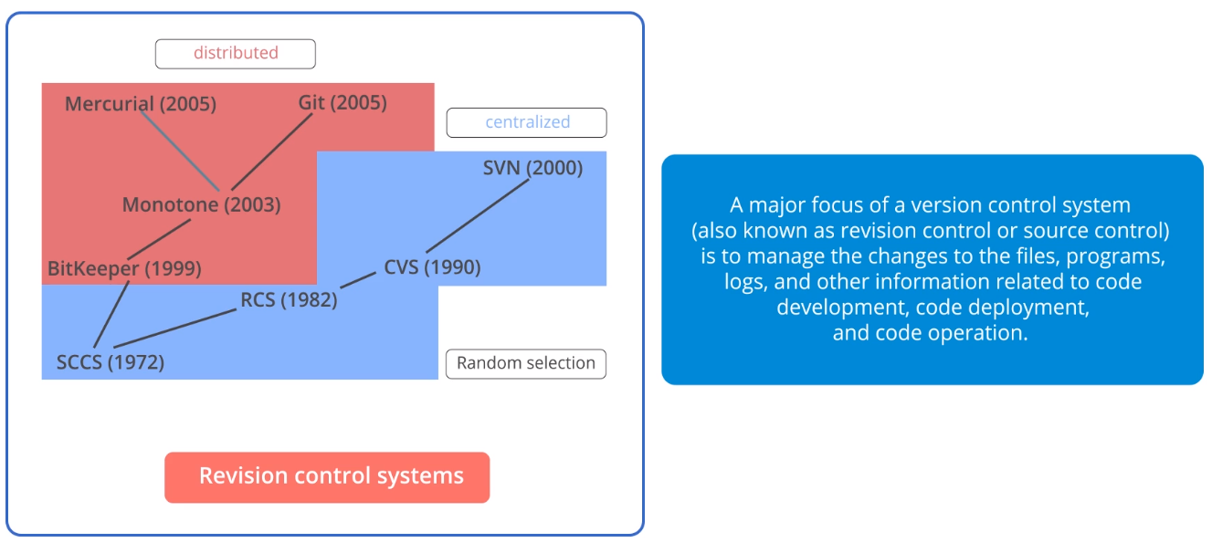

Need for Version Control Systems:

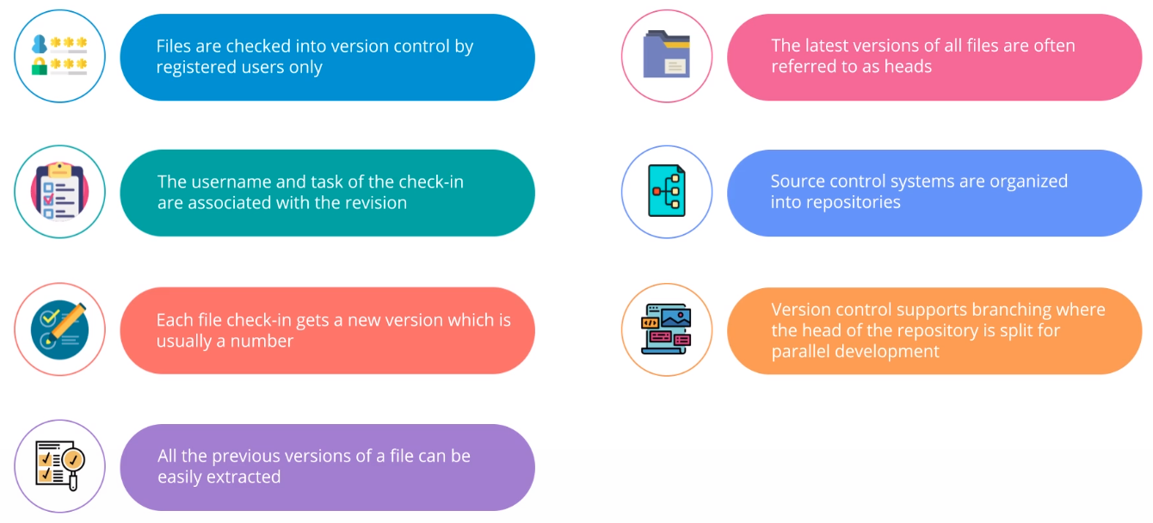

Repositories: Dos and Don‘ts:

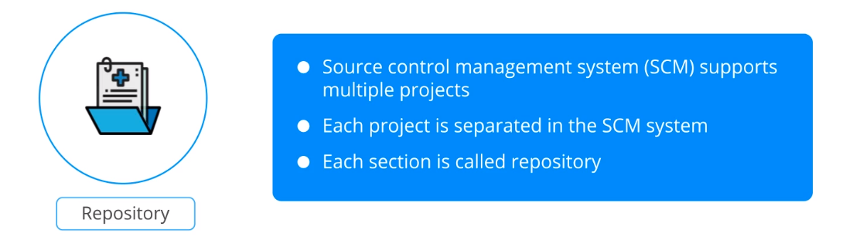

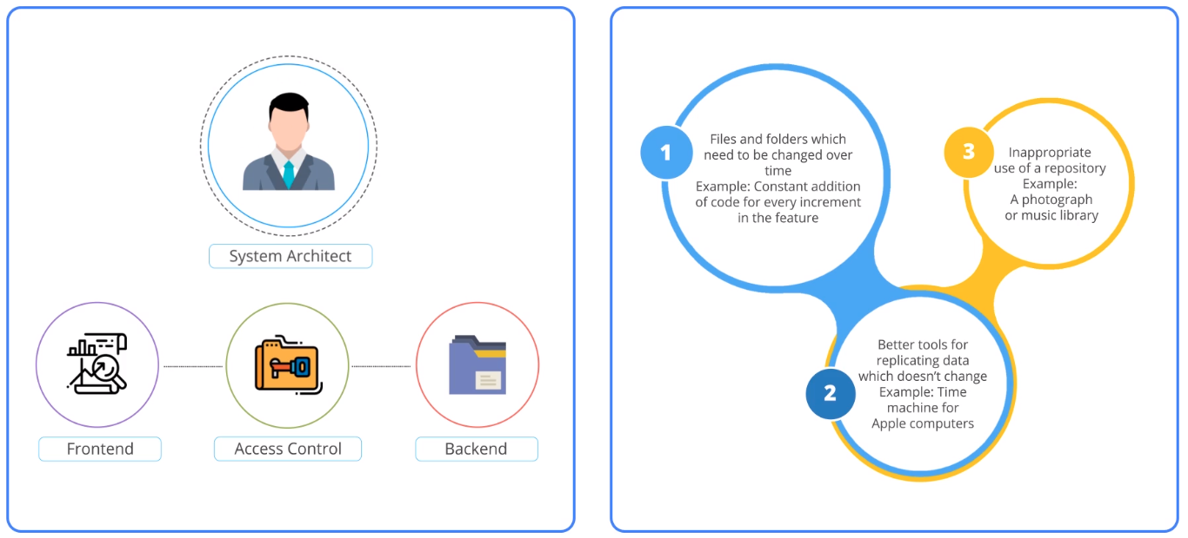

Popular Version Control Systems:

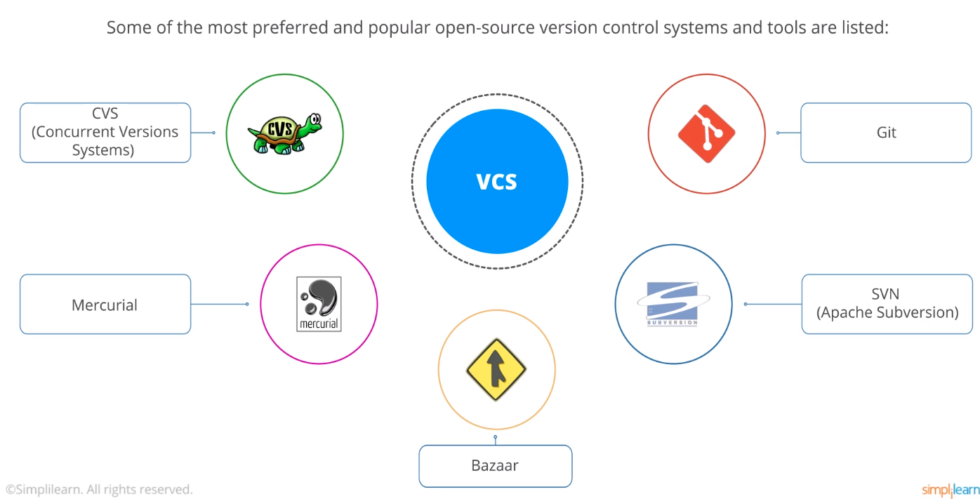

**3.3 Role of Version Control Systems**

Importance of Version Control Systems:

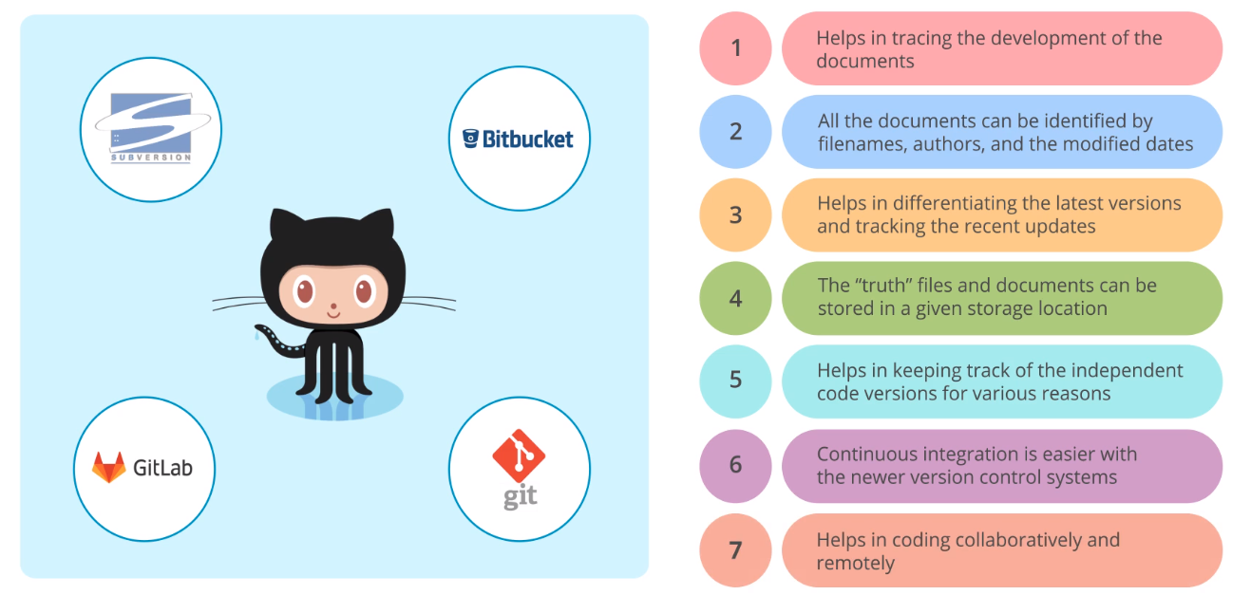

Benefits of Version Control Systems in a DevOps Environment:

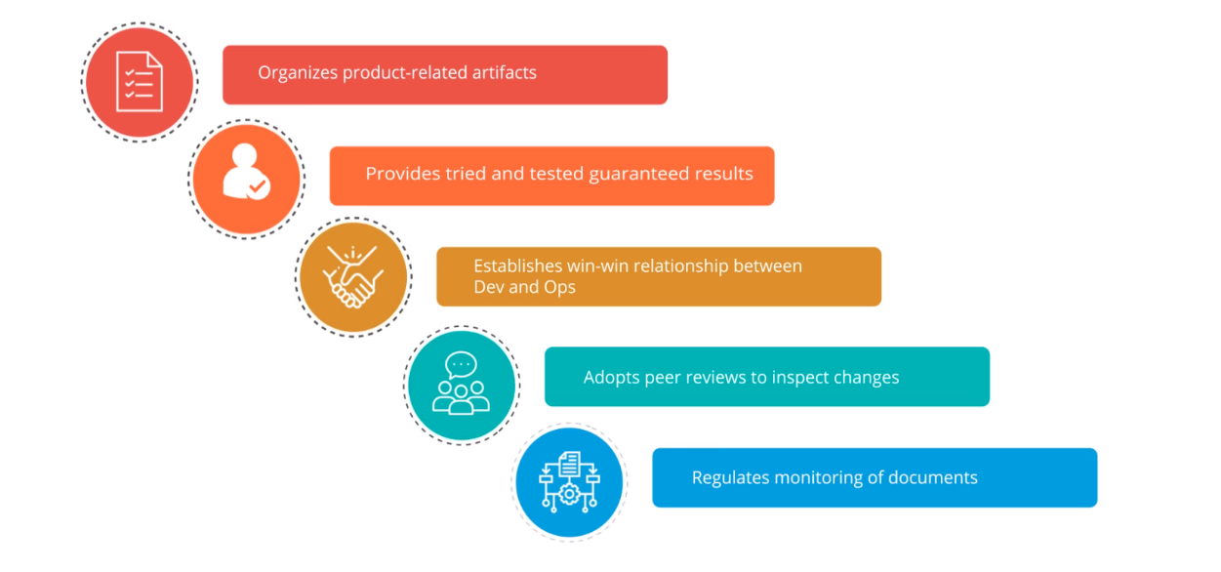

**3.4 Types of Control Systems and Their Supporting Tools**

Types of Source Control Systems:

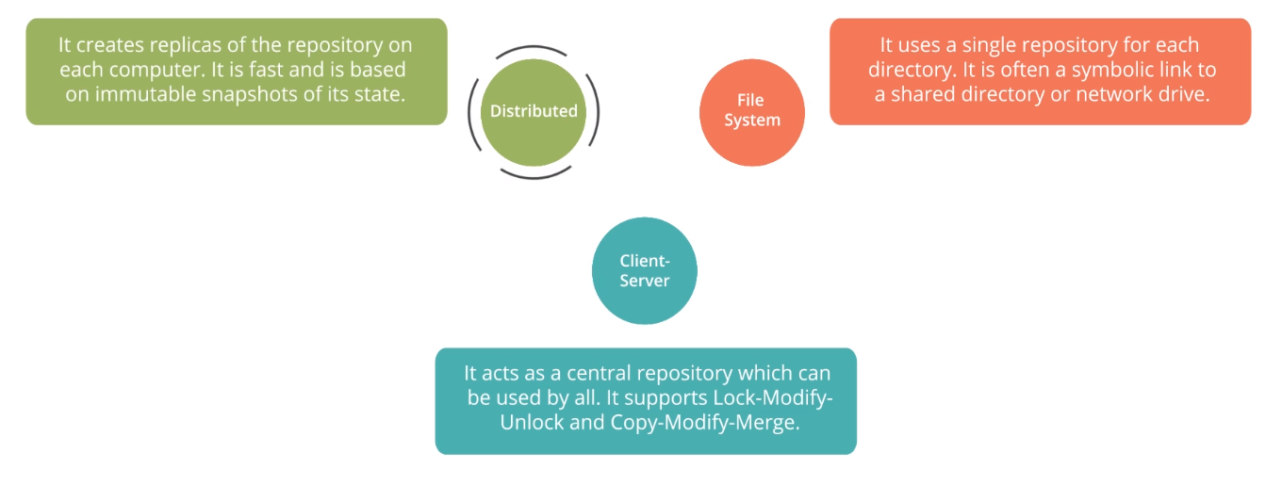

File-based Source Control Systems:

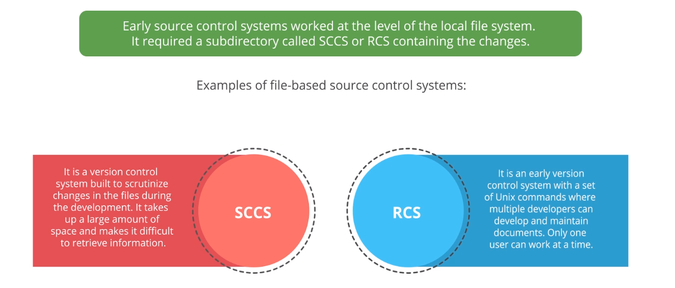

Client-Server-based Source Control Systems:

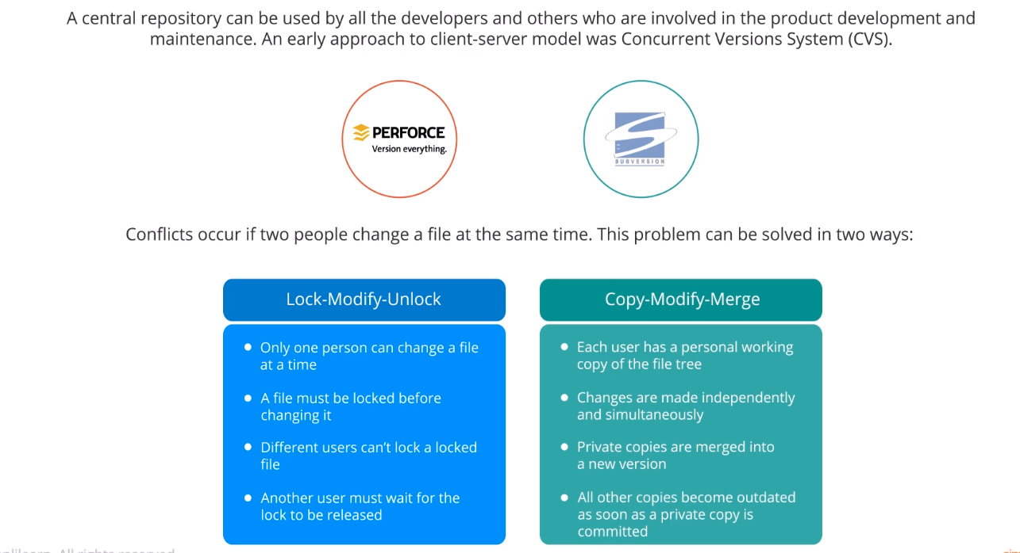

Distributed Source Control Systems:

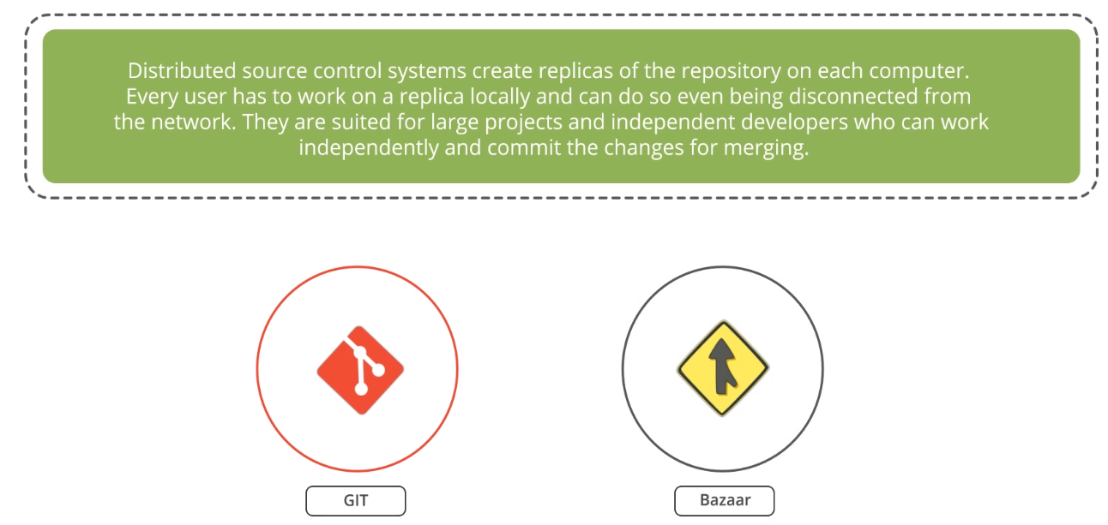

Features of Distributed System:

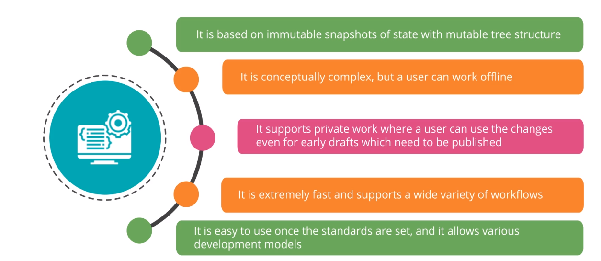

Repositories are key tools for DevOps:

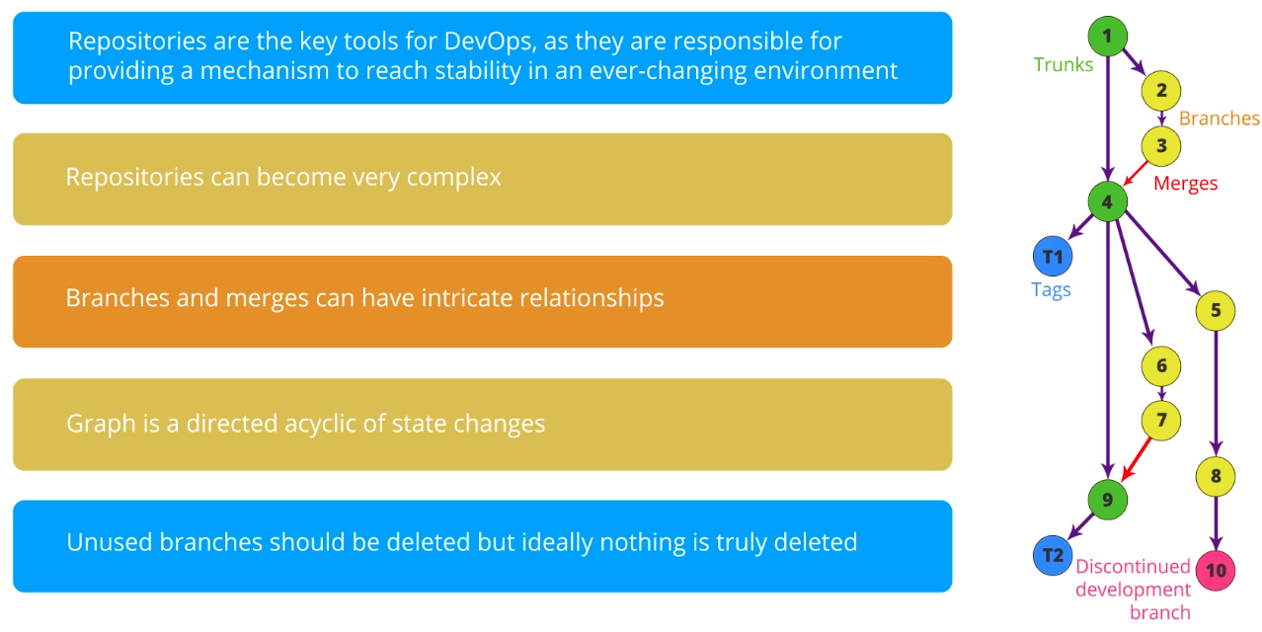

Types of Version Control Systems (Git):

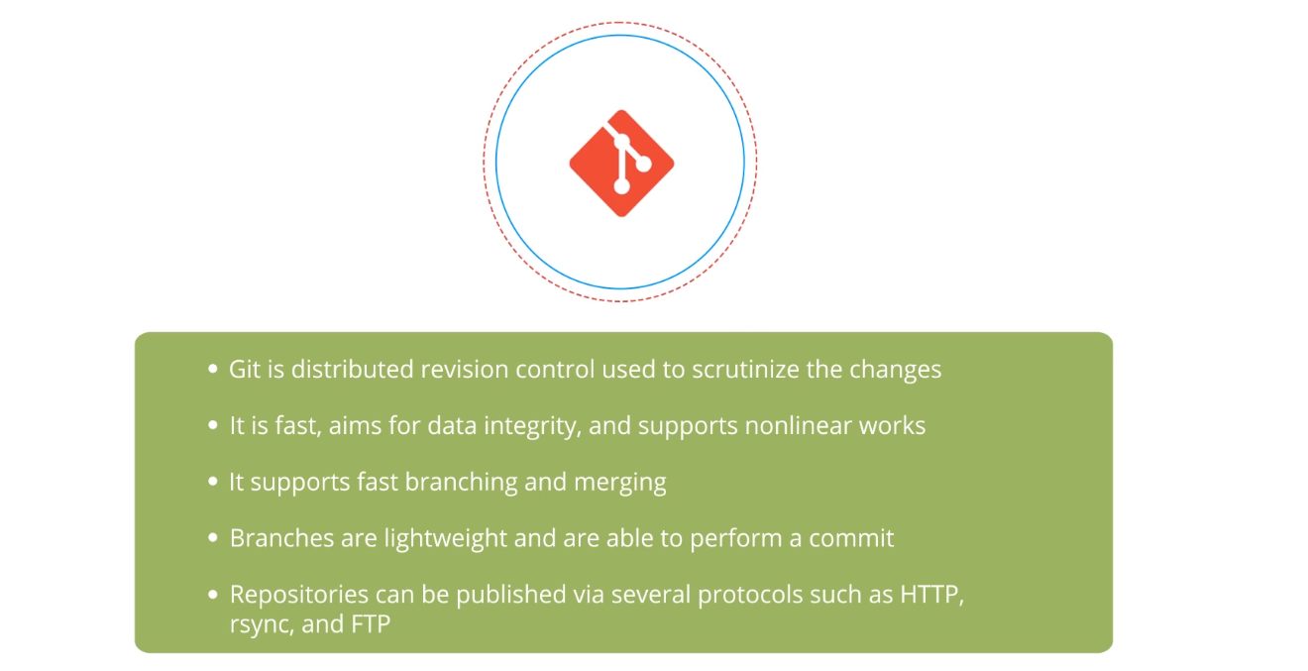

Types of Version Control Systems (Bazaar):

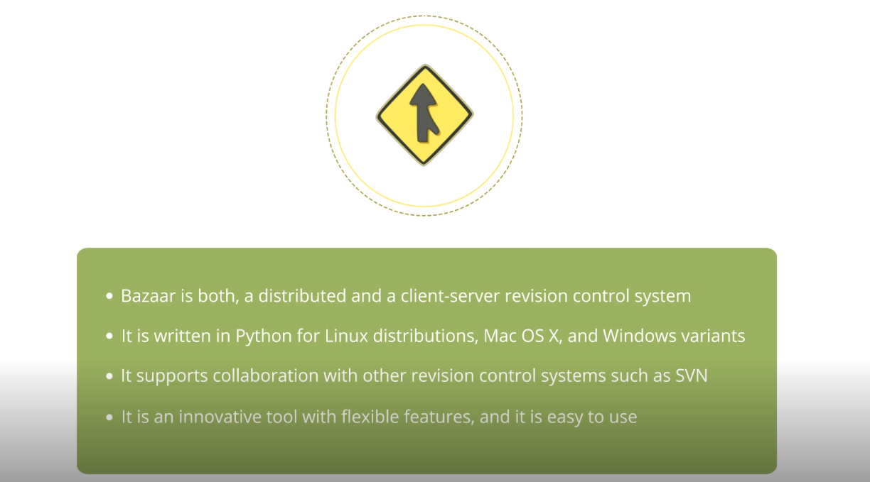

Types of Version Control Systems (Subversion):

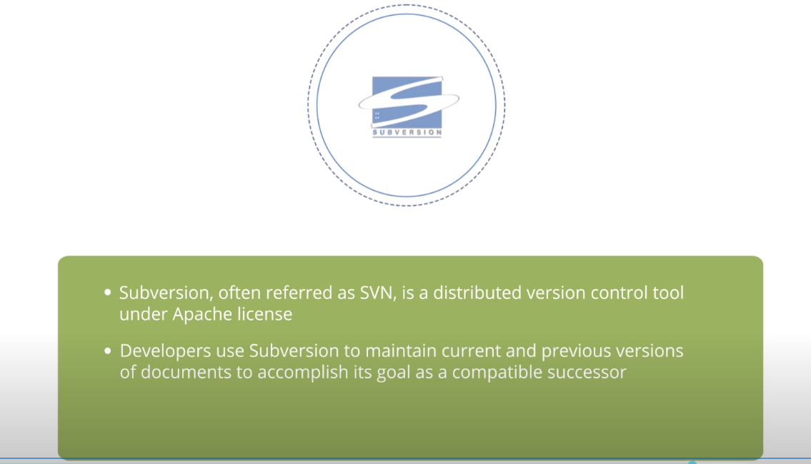

Types of Version Control Systems (mercurial):

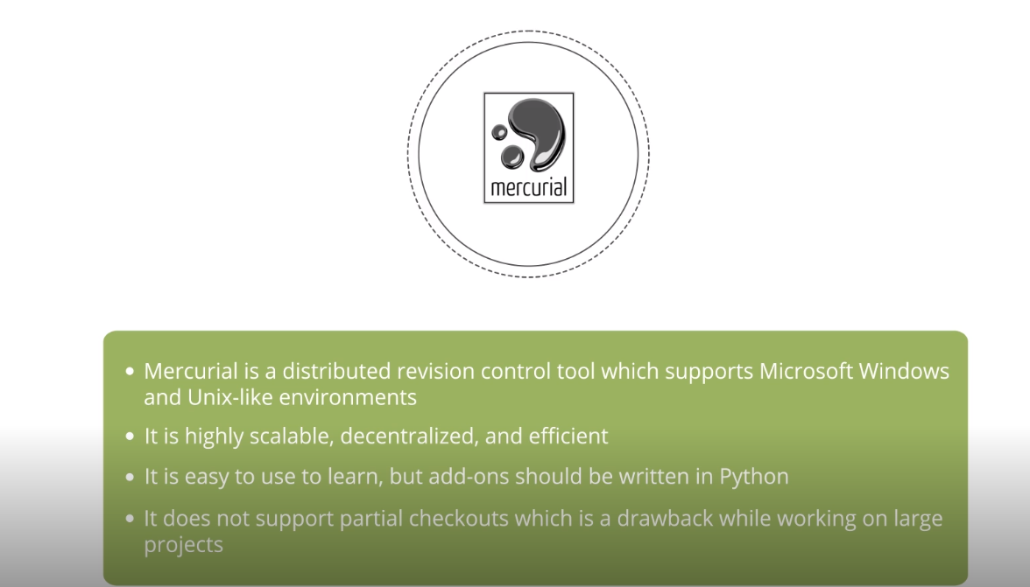

Types of Version Control Systems (cvs):

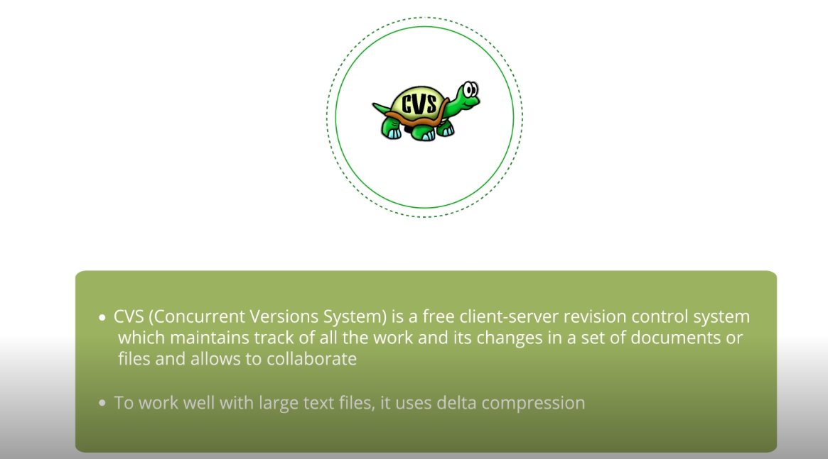

Types of Version Control Systems (perforce):

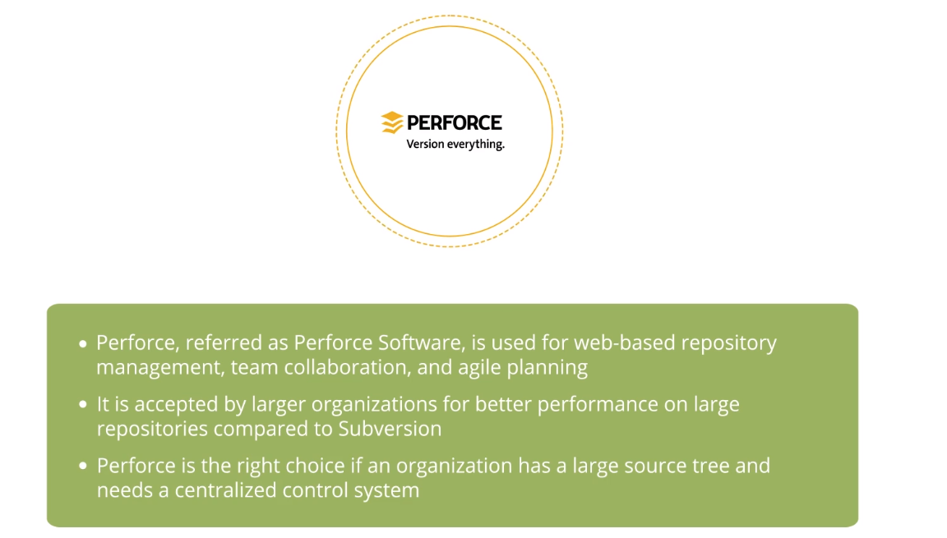

Types of Version Control Systems (rcs):

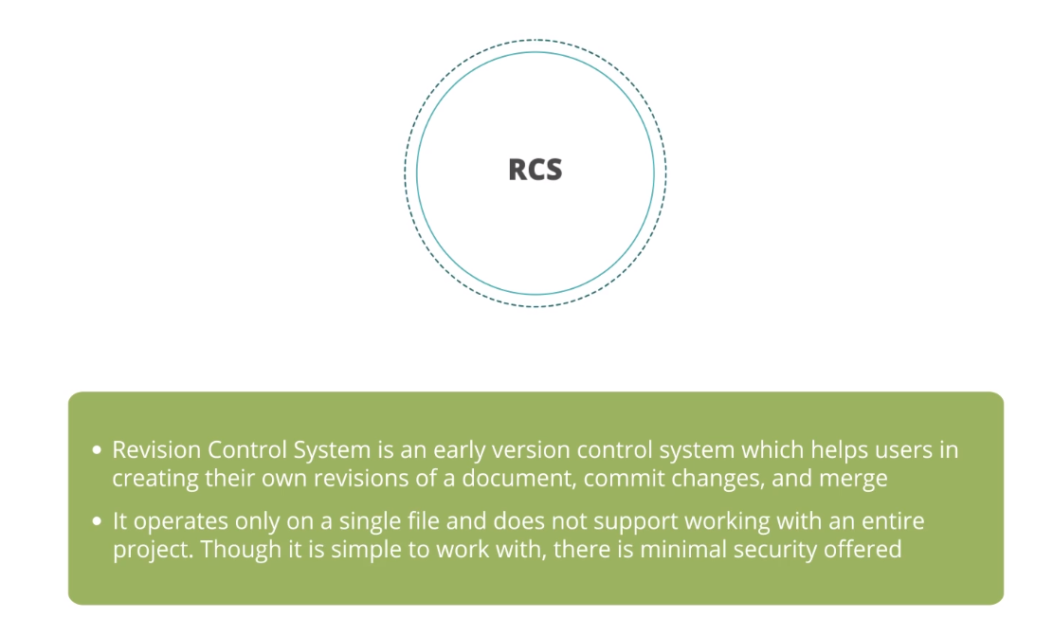

Types of Version Control Systems (sccs):

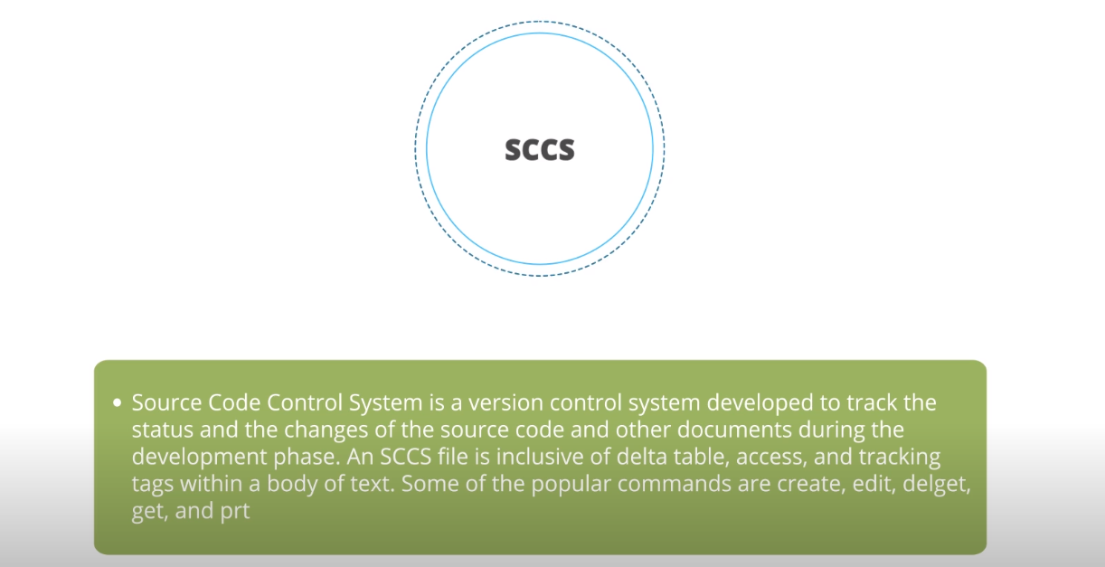

Types of Version Control Systems (monotone):

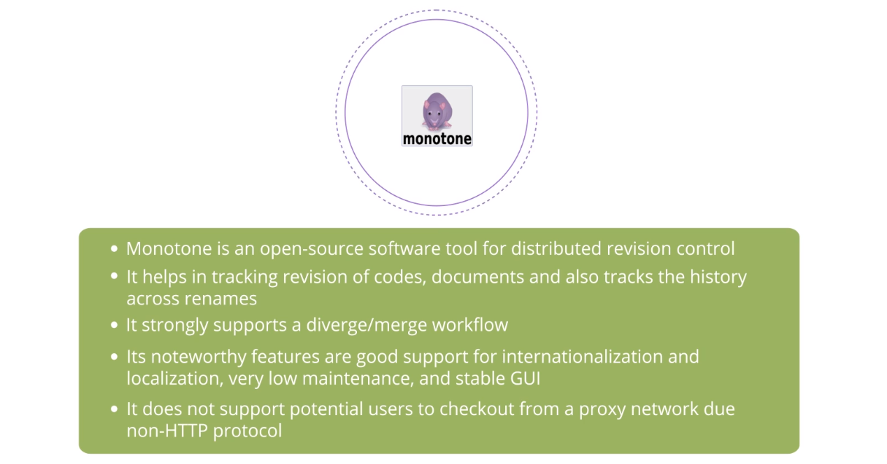

Types of Version Control Systems (plastic scm):

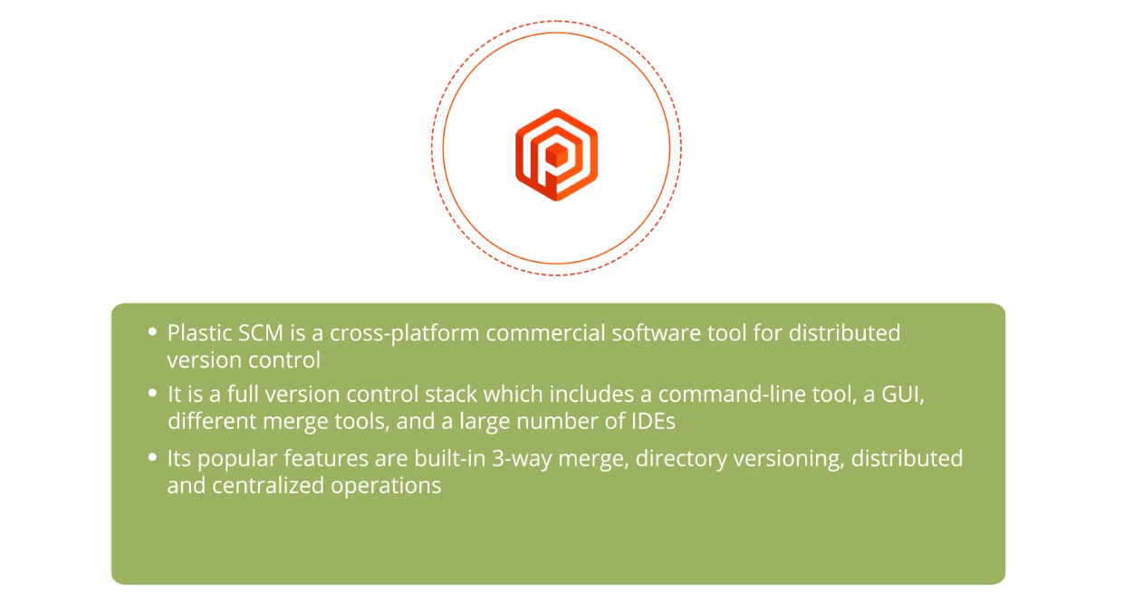

**3.5 Overview of Git**

Popular Terminologies:

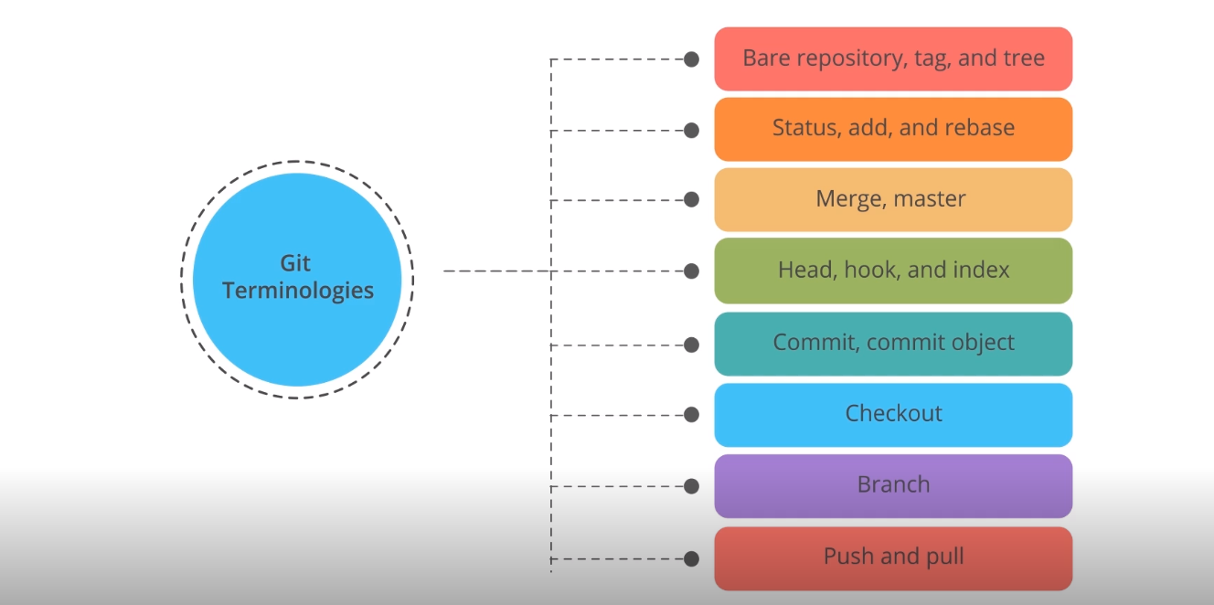

Bare repository, tag and tree:

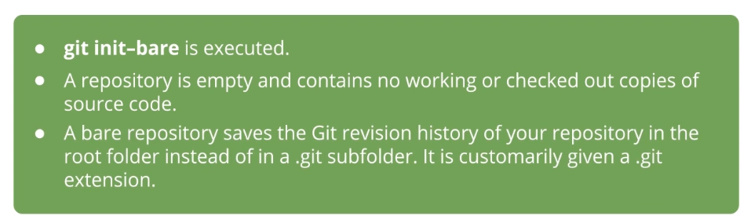

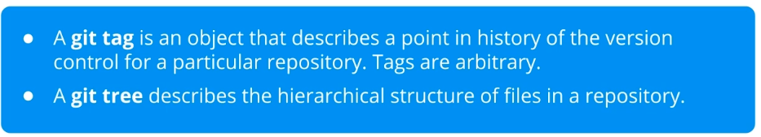

Status, add and rebase:

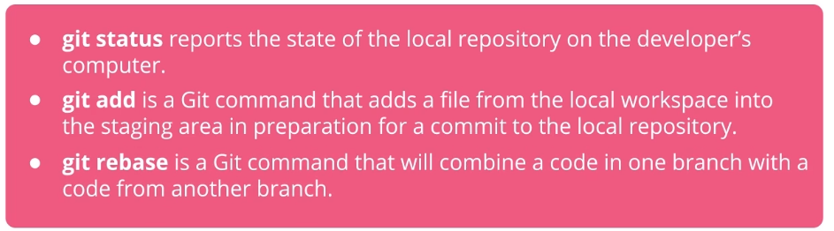

Head, hook and index:

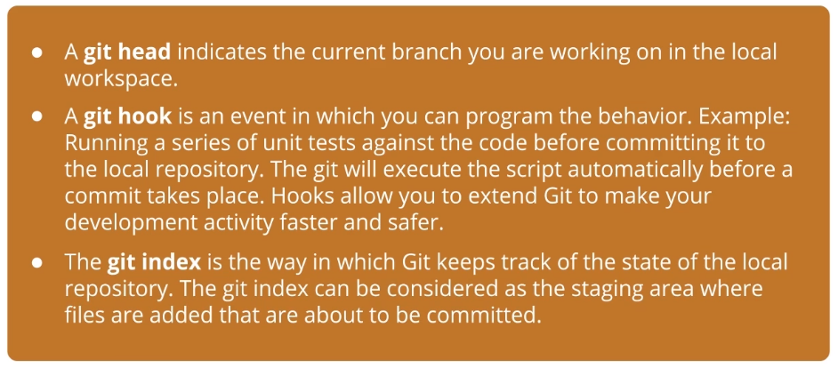

Commit, commit object:

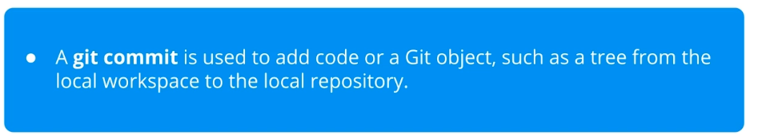

Checkout:

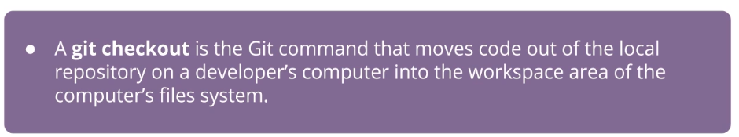

Branch:

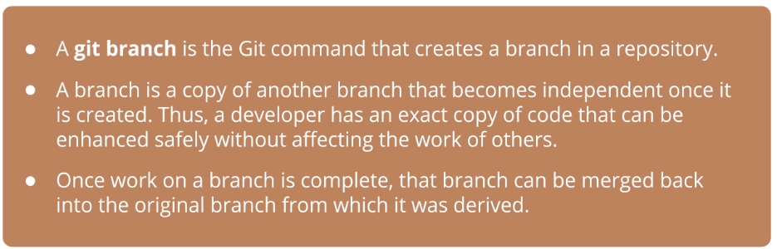

Push and pull:

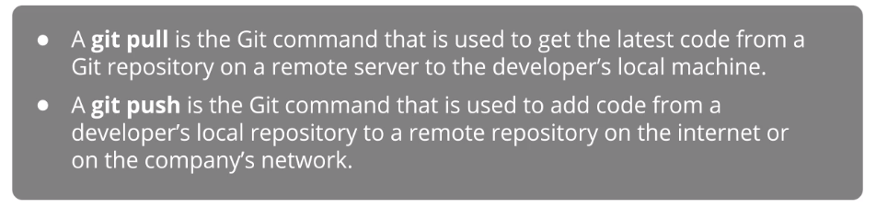

Git Workflow:

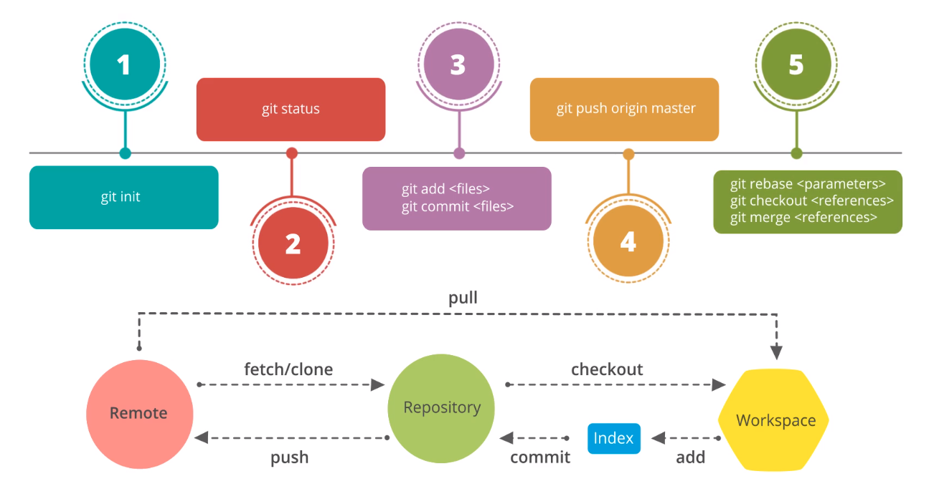

**3.6. Overview of Source code and Version Control Hosts**

Source Code Hosting Facility:

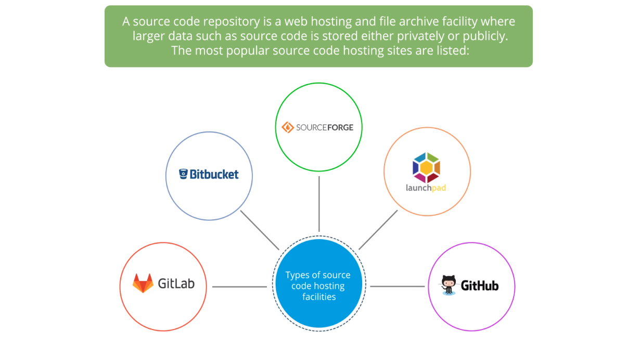

Supported features:

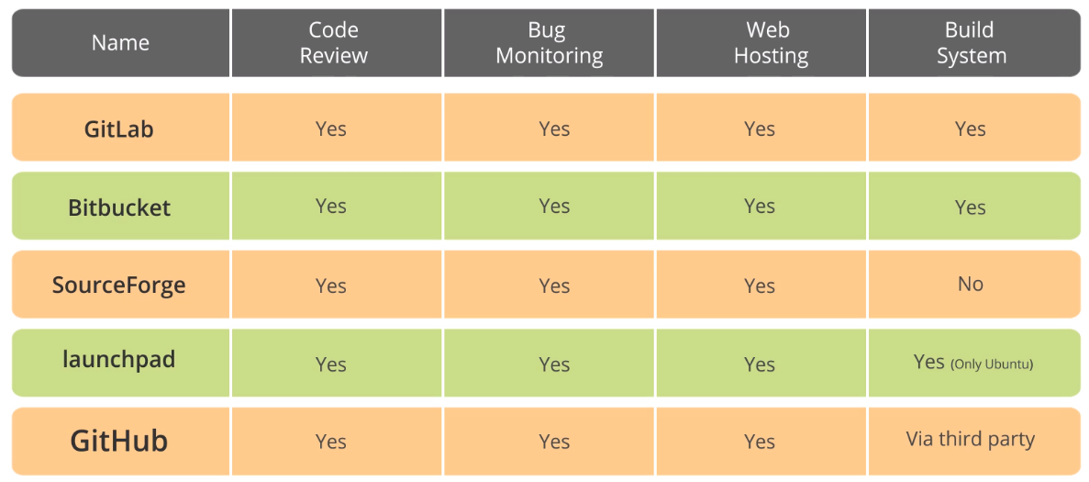

Supported Version Control Systems:

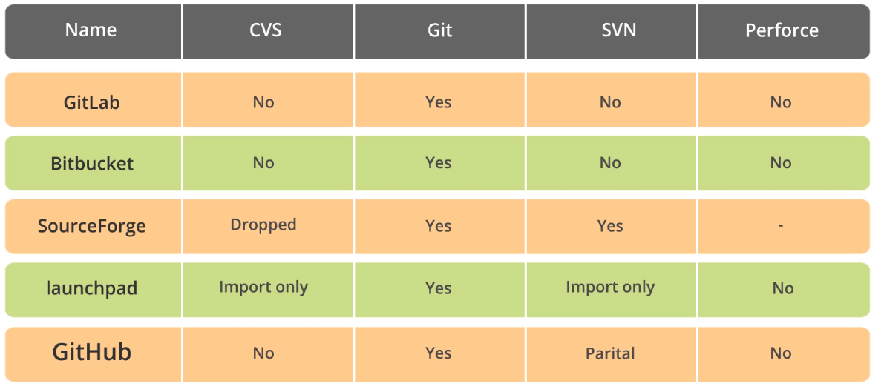

Popularity and the Community Usage:

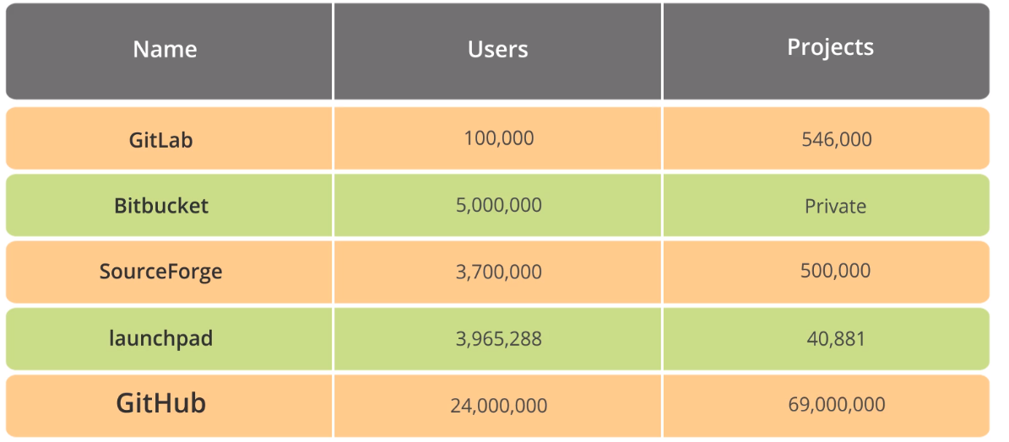

**3.7 Deploy the files to GitHub via Git**

Exercise

**3.9 Key Takeaways**

